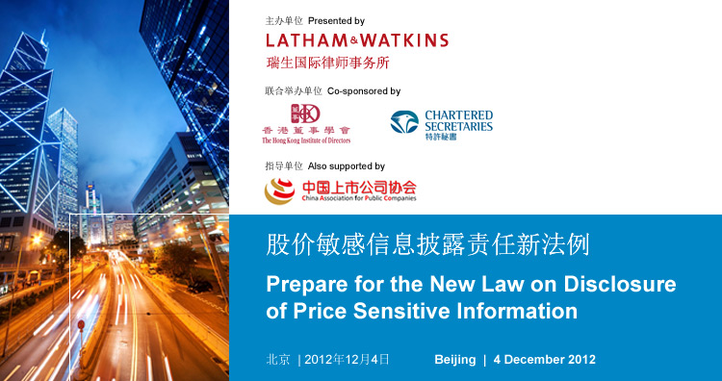
此为免费研讨会  2012年12月4日，星期二  会议時間: 13:30 – 17:30  招待酒会17:30 – 19:00  北京香港马会会所  北京市东城区金宝街68号  报名参加  请于2012年11月23日前点击此处报名参加会议 |  | A complimentary conference  Tuesday, 4 December 2012  Conference: 13:30 – 17:30  Drinks reception: 17:30 – 19:00  Beijing Hong Kong Jockey Club  No. 68, Jinbao Street, Dongcheng District, Beijing  RSVP  Please register here by 23 November 2012
关于香港上市公司股价敏感信息披露责任的新法例将于2013年1月1日生效。新制度规定了香港上市公司及其董事与高级人员披露股价敏感资料的法定责任及违反将面临的民事制裁。  全球领先的瑞生国际律师事务所与香港董事学会、香港特许秘书公会联合举办本次研讨会，中国上市公司协会作为指导单位参与本研讨会，旨在向上市公司董事、高级管理人员、公司法律顾问、公司秘书、监管和合规人员介绍这项新制度。在硏讨实际案例讲述法例的新要求后，我们还会提出确保企业合规及避免违规风险的实践步骤。新的违法制裁包括罚款高达港币800万元及民事索赔。  若干大型上市公司的代表将作为论坛嘉宾参加本次研讨会，就有关问题发表意见和进行研讨。  请参加我们的研讨会，为遵守新法例作好准备！ |  | New legislation on the disclosure of price sensitive  information by Hong Kong listed companies will come into force on 1 January 2013. The new law creates statutory obligations on Hong Kong listed companies and their directors and officers with legal liabilities for breaches of the law.  Leading international law firm Latham & Watkins, in conjunction with The Hong Kong Institute of Directors (HKIoD) and The Hong Kong Institute of Chartered Secretaries (HKICS), is presenting this timely conference to update officers of listed corporations, including directors, senior management, in-house lawyers, company secretaries, regulatory and compliance personnel, on the new requirements. The conference is also supported by China Association for Public Companies. In addition to discussing some practical case studies to show how the requirements have changed, we will also discuss ways to ensure compliance and avoid breaching the law. The new penalties include fines of up to HK$8 million and civil claims for damages.  Representatives from large listed companies will speak and participate in the conference’s panel discussions.  Join us and be armed to comply with the new law!
演讲嘉宾： |  | Guest speakers:
• 梁定邦先生,中国银行股份有限公司及中国人寿保险股份有限公司独立非执行董事  • 何龙灿主任,中国上市公司协会  • 魏伟峰博士,香港特许秘书公会副会长 |  | • Mr. Anthony Francis Neoh, Independent Non-executive Director, Bank of China Limited and China Life Insurance Company Limited  • Dr. He Longcan, Director, China Association for Public Companies  • Dr. Maurice Ngai, Vice President, Hong Kong Institute of Chartered Secretaries
议题： |  | What we will discuss:
• 香港为何要将上市公司股价敏感資料披露责任法律化？  • 新旧股价敏感資料披露体制有何差别？  • 上市公司何时及如何披露股价敏感資料？是否存在豁免法定披露责任的条款？  • 如何判定上市公司是否违反了法定披露责任？  • 香港证监会和香港联交所扮演了什么样的新角色?  • 香港的股价敏感信息披露新制度较中國和美國的相关制度有何区别？  • 在新体制下违反法定义务有甚麼责任？  • 上市公司及其管理人员在确定交易时应采取什么实际步骤以确保符合法律规定？ |  | • Why did Hong Kong codify the requirements to disclose price sensitive information (PSI) into statute?  • What are the differences between the old and the new PSI regime?  • When and how should listed companies make PSI disclosure? Are there any exemptions to the statutory disclosure obligations?  • When does a listed company breach the statutory disclosure obligations?  • What are the new roles of the Securities and Futures Commission and the Stock Exchanges of Hong Kong?  • What are the major differences among the disclosure regimes in Hong Kong, the PRC and the US?  • What are the consequences of breach under the new law?  • What practical steps should listed companies and their officers take to protect themselves?
报名参加  请于2012年11月23日前点击此处报名参加会议  如有疑问请联系：  谭诗慧 (+852.2912.2503)  电子信箱teresa.tam@lw.com  李晓娜(+86.10.5965.7029)  电子信箱amy.li@lw.com |  | RSVP  Please register here by 23 November 2012  Enquiries:  Teresa Tam (+852.2912.2503)  teresa.tam@lw.com  Amy Li (+86.10.5965.7029)  amy.li@lw.com
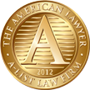 | Latham & Watkins Named to The American Lawyer’s “A-List” from 2002-2012  瑞生国际律师事务所由2002-2012年一直名列《美国律师》杂志  “最佳律师事务所名录”
取消订阅及联系信息
如您欲更新您的联系资料或定制从本所处获得的信息，请通过http://events.lw.com/reaction/subscriptionpage.html订阅本所的客户邮件；为确保邮件的送达，请将LathamMail@lw.com添加至您的电子邮箱通讯录。如您欲终止邮件订阅，请点击unsubscribe@lw.com或在主题栏中输入“取消订阅”回复本邮件。
美国瑞生律师事务所在世界各地以根据（美国）达拉华州法律组建的有限责任合伙形式运作，其中在英国、法国、意大利及新加坡的业务以关联的有限责任合伙形式进行，在香港和日本的业务则以关联合伙形式进行。美国瑞生律师事务所与Law Office of Salman M. Al-Sudairi. 联营，一起在沙特阿拉伯经营业务。美国瑞生律师事务所在卡塔尔持有卡塔尔金融中心管理局的许可。©美国瑞生律师事务所2012年版权。所有权利均保留为专用。
Unsubscribe and Contact Information
If you wish to update your contact details or customize the information you receive from Latham & Watkins, please visit http://www.lw.com/LathamMail.aspx to subscribe to our client mailings. To ensure delivery into your inbox, please add LathamMail@lw.com to your e-mail address book. If you wish to be removed from our distribution, please click this link, unsubscribe@lw.com, or reply to this message with "Unsubscribe" in the subject line.
This e-mail was generated from Latham & Watkins LLP, located at 555 West Fifth Street, Suite 800, Los Angeles, CA 90013-1010; Phone: +1.213.891.1200. Latham & Watkins operates worldwide as a limited liability partnership organized under the laws of the State of Delaware (USA) with affiliated limited liability partnerships conducting the practice in the United Kingdom, France, Italy and Singapore and as affiliated partnerships conducting the practice in Hong Kong and Japan. Latham & Watkins practices in Saudi Arabia in association with the Law Office of Salman M. Al-Sudairi. In Qatar, Latham & Watkins LLP is licensed by the Qatar Financial Centre Authority. © Copyright 2012 Latham & Watkins. All Rights Reserved.

